**Hydration Logger – Try-Except-Finally Assignment**

Author: Ian Patricio

Date: August 02, 2025

Language: Python

Purpose: This program promotes hydration awareness by allowing users to log their daily water intake. It demonstrates the use of try, except, and finally blocks in Python while displaying helpful statistics and always ending with a positive health message.

**Pseudocode**  
# Print welcome message and description  
print welcome message and hydration info  
  
# Try to get number of hydration entries from user  
try:  
 entries = input as integer  
 if entries <= 0:  
 raise ValueError  
  
 # Initialize log to store timestamps and water intake  
 log = empty list  
  
 # For each hydration entry  
 for i in range(1 to entries):  
 try:  
 glasses = input as float  
 if glasses < 0:  
 raise ValueError  
 timestamp = current time  
 add (timestamp, glasses) to log  
 except ValueError:  
 print error message and skip entry  
  
 # Calculate statistics  
 total = sum of glasses in log  
 average = total / number of entries  
 goal = 8  
 goal_diff = total - goal  
  
 # Print hydration summary  
 print total, average, goal_diff, and encouragement message  
  
except ValueError:  
 print error message about invalid number of entries  
  
finally:  
 print hydration health tip and thank you message  
  
# End of program

**Source Code**

*"""*

*Title: Daily Hydration Logger with Statistics*

*Author: Ian Patricio*

*Description:*

*This program tracks the user's daily water intake in glasses and logs it with a timestamp.*

*It calculates the total, average intake, and how close the user is to the daily goal.*

*The program demonstrates exception handling using try, except, and finally blocks.*

*Promotes health awareness through hydration encouragement and daily logging.*

*"""*

from datetime import datetime

def hydration_logger():

print("=" * 69)

print("Daily Hydration Logger – Stay Refreshed!")

print("Track your water intake and see your hydration stats.")

print("=" * 69)

log = []

try:

entries = int(input("\nHow many times did you drink water today? (e.g., 3 times): "))

if entries <= 0:

raise ValueError("Number of entries must be a positive number.")

for i in range(1, entries + 1):

try:

glasses = float(input(f" ➤ Entry #{i}: How many glasses did you drink? "))

if glasses < 0:

raise ValueError("Glasses cannot be negative.")

timestamp = datetime.now().strftime("%H:%M:%S")

log.append((timestamp, glasses))

except ValueError as ve_inner:

print(f" Skipping entry due to error: {ve_inner}")

continue

total = sum(g[1] for g in log)

average = total / len(log) if log else 0

goal = 8 # 8 glasses per day recommended

goal_diff = total - goal

print("\nHydration Summary:")

print(f" Entries logged: {len(log)}")

print(f" Total water intake: {total:.1f} glasses")

print(f" Average per entry: {average:.2f} glasses")

print(f" Goal difference: {'+' if goal_diff >= 0 else ''}{goal_diff:.1f} glasses")

if total >= goal:

print(" You met your hydration goal today! Great work! 🌟")

else:

print(" Keep sipping! You're almost there!")

except ValueError as ve:

print(f"\nInput Error: {ve}")

finally:

print("\nWellness Tip: Drink a glass of water when you wake up, before meals, and before bed.")

print("Thank you for using the Hydration Logger")

# Run the program

hydration_logger()

**Screenshots:**

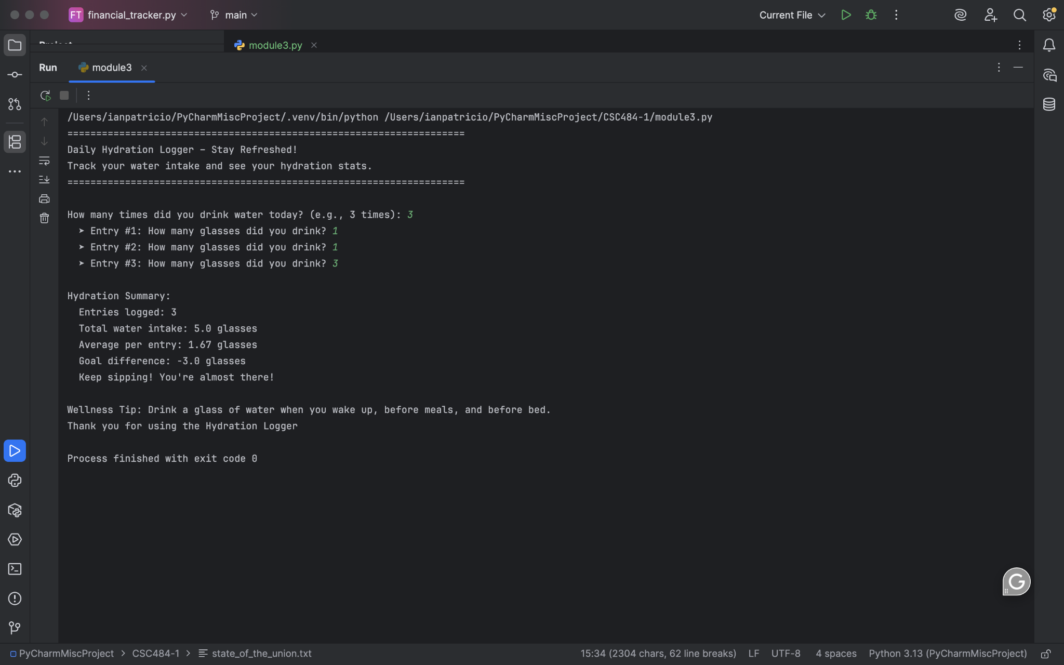

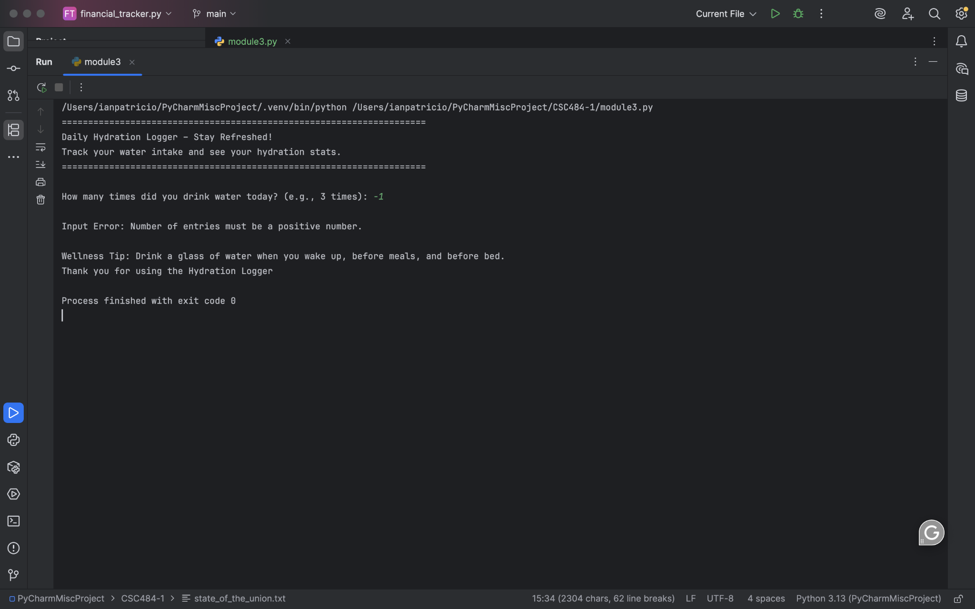

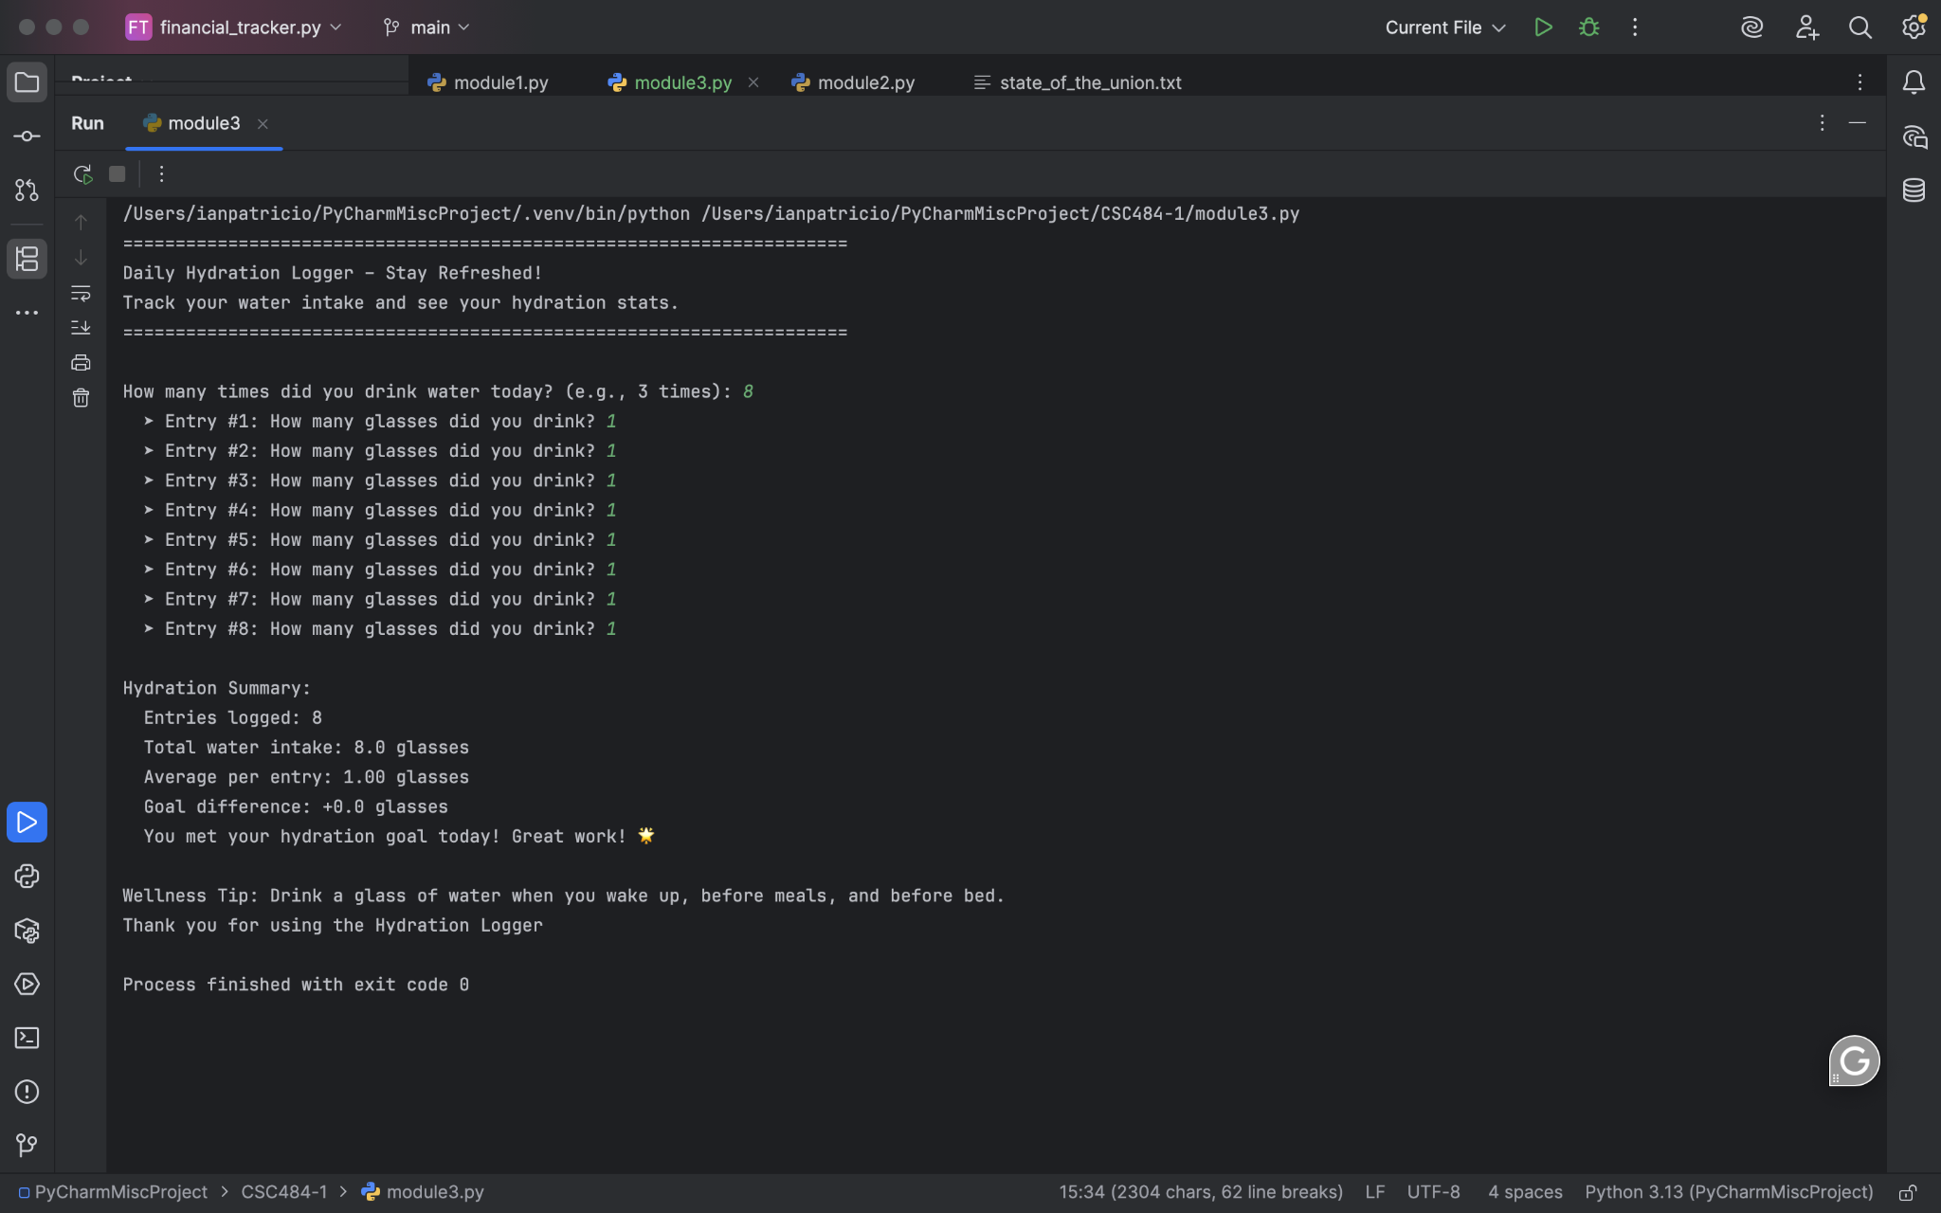

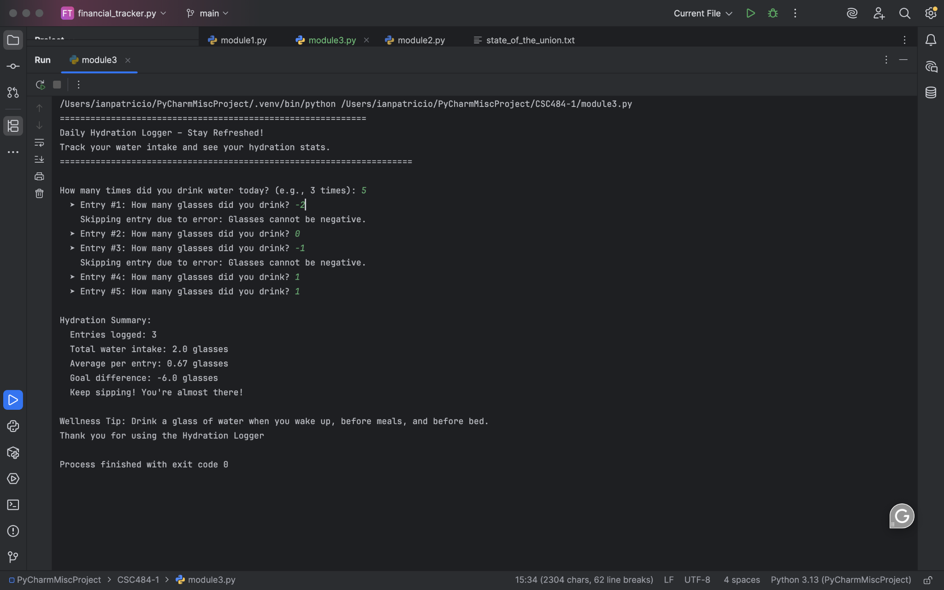

**Git Repository:**

https://github.com/ianpatricio-csuglobal/CSC484-1